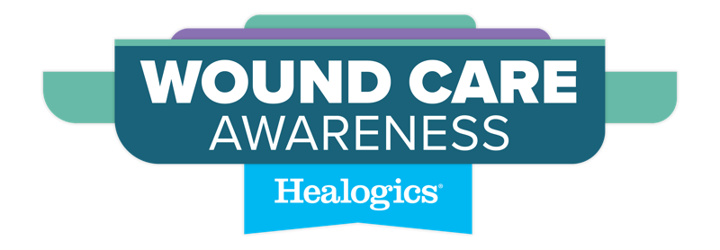

WOUND CARE AWARENESS

Advanced wound care and its benefits to the community we serve.

Wound Care Matters
Nearly 7 million people in the U.S. are currently living with a chronic wound, which is only expected to grow. Today, one in four families has a family member with a chronic wound. People living with a chronic wound may experience chronic pain, social isolation, depression and anxiety, and are at risk for hospitalization, infection, and even amputation.

Chronic wounds affect 14.5 percent of Medicare beneficiaries yearly, generating over $50 billion in annual associated healthcare costs. The incidence of non-healing wounds is expected to rise at a rate of two percent annually over the next decade, fueled by an aging population and increased rates of diabetes, obesity, cardiovascular disease and certain cancers. If left untreated, a staggering 30% of chronic wounds will result in amputation, and after an amputation, the five-year mortality rate is approximately 50%.

The Solution
Come Heal with Us! Foot exams by a medical professional, when paired with self-foot checks, are key to the early identification of wounds and may lead to improved outcomes. Early wound treatment can reduce amputation risk by about half, when combined with a multi-specialty wound care team. Advanced therapies that aid wound closure and new tissue growth may include - total contact casting, negative pressure wound therapy and hyperbaric oxygen therapy (HBOT).

Wound Care Awareness is an opportunity for us to educate patients, caregivers and physicians about chronic wounds and the advanced wound care treatment options available. Join us in our mission to heal more wounds, empowering people to receive the care they need and live the life they deserve.

If you or someone you know is experiencing a chronic non-healing wound, it is essential to find advanced care. For more information or to schedule an appointment, contact the [Wound Care Center name] at [Center Address] or [Center Phone Number], where healing happens.
Join us in our mission to heal more wounds, empowering people to receive the care they need and live the life they deserve.
©2024 Healogics, LLC. All Rights Reserved.

